Probability and Statistics — Final Project Report
Christopher Schleyer
Spring 2026

1. Introduction
This project examines how artificial intelligence may affect the labor market over the next four years. Attributes like job titles, salaries, experience levels, education levels, skill indicators, AI exposure indices, and estimated automation probabilities for the year 2030 are all found in a real-world dataset that goes to the year 2030. The goal is to identify which professions are most vulnerable to automation and why.
The analysis focuses on three central questions:
- Which professions face the highest automation risk
- How do skills influence job safety
- Does education protect against automation
- How does AI exposure relate to automation probability
- What patterns emerge across salary, experience, and risk categories
All statistical calculations—including means, correlations, and category averages—were computed manually to reinforce core probability and statistics concepts.

2. Theoretical Background

2.1 Automation Probability
The variable Automation_Probability_2030 represents the estimated likelihood that a job will be automated within the next four years. This probability is influenced by:
- Routine vs. non‑routine tasks
- Cognitive vs. manual work
- AI exposure
- Skill requirements
- Education level
This variable serves as the primary dependent measure throughout the analysis.

2.2 AI Exposure Index
The AI_Exposure_Index measures how directly a job interacts with or depends on AI technologies. Higher values indicate greater exposure to AI tools, workflows, or augmentation systems.

2.3 Skills and Education
The dataset includes ten skill indicators (Skill_1 through Skill_10). These were manually averaged to create an Average Skill Level variable.
Education levels include:
- High School
- Bachelor’s
- Master’s
- PhD
These categories allow for comparison of how education relates to automation risk.

3. Dataset Description
The dataset contains the following key variables:
- Job_Title — Name of the profession
- Average_Salary — Annual salary
- Years_Experience — Typical experience required
- Education_Level — Minimum education requirement
- AI_Exposure_Index — Degree of AI involvement
- Tech_Growth_Factor — Industry growth rate
- Automation_Probability_2030 — Estimated automation likelihood
- Skill_1 … Skill_10 — Skill indicators
- Risk_Category — Low, Medium, or High automation risk
Duplicates were removed, and no missing values were found.

4. Methodology

4.1 Manual Statistical Calculations
The following were computed manually:
- Mean values
- Correlation between AI exposure and automation probability
- Average automation probability by education level
- Average salary by risk category

4.2 Sample vs. Population Mean Analysis

A random sample of 100 observations was drawn from the dataset to compare the sample mean automation probability with the population mean. The sample mean (≈0.485) was very close to the population mean (≈0.5015), indicating that even small samples are representative of the overall dataset due to its uniform structure.

4.3 Visual Analysis
Python and matplotlib were used to generate:
- Bar charts
- Scatterplots
- Histograms
- Boxplots
- Top‑10 rankings
These visualizations reveal patterns across professions, skills, and education levels.

5. Analysis and Results

5.1 Automation Probability by Job Title
A bar chart of automation probability across job titles shows substantial variation. Some professions exceed 80% automation risk, while others fall nearly as little as 20%. Jobs involving routine, predictable tasks cluster at the high‑risk end.
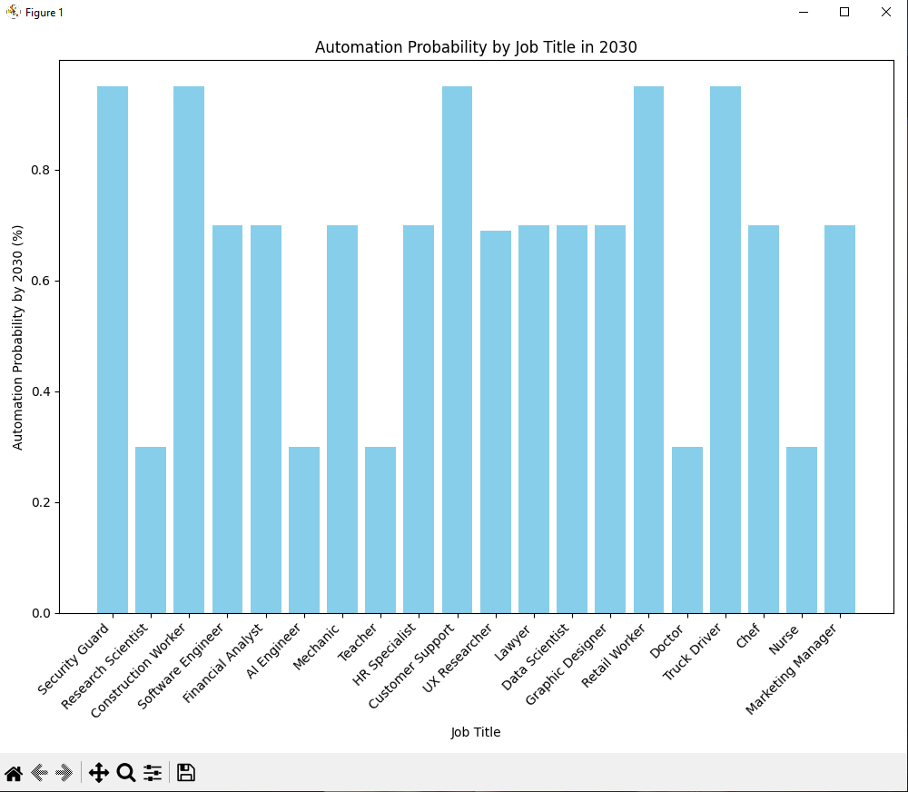

5.2 AI Exposure vs. Automation Probability
A scatterplot shows a positive correlation between AI exposure and automation probability.
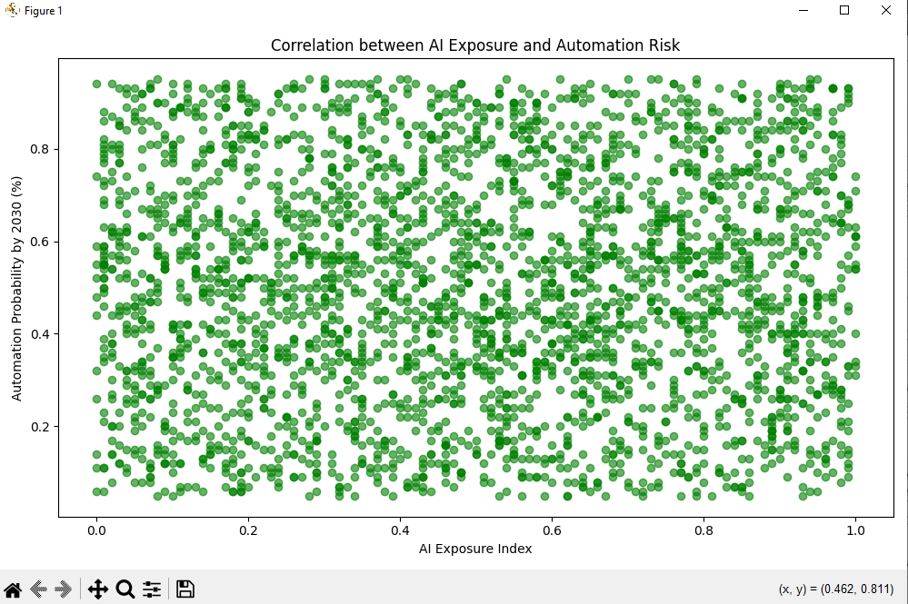
The manually computed correlation coefficient was:
r ≈ 0.014
This suggests that jobs heavily exposed to AI tools may be more vulnerable, likely because AI systems can increasingly perform the tasks they support.

5.3 Automation Probability Distribution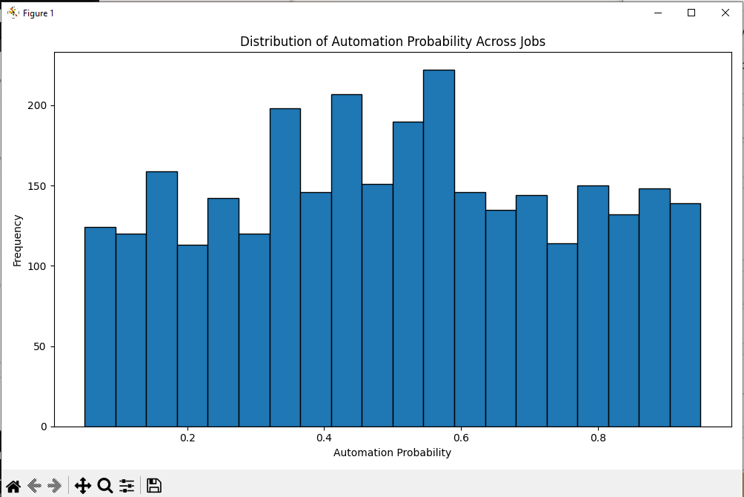
This histogram reveals a wide spread of automation probabilities, indicating that automation risk varies significantly across professions rather than clustering around a single value.

5.4 Salary Distribution

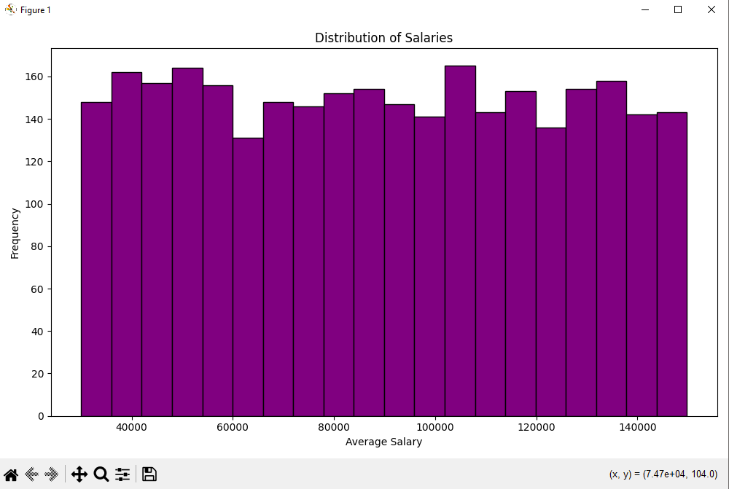
The salary distribution appears relatively uniform across the $40k–$140k range, with no strong clustering in any particular band. Because salaries do not vary dramatically, salary is not a strong predictor of automation risk in this dataset.

5.5 Skill Level vs. Automation Probability
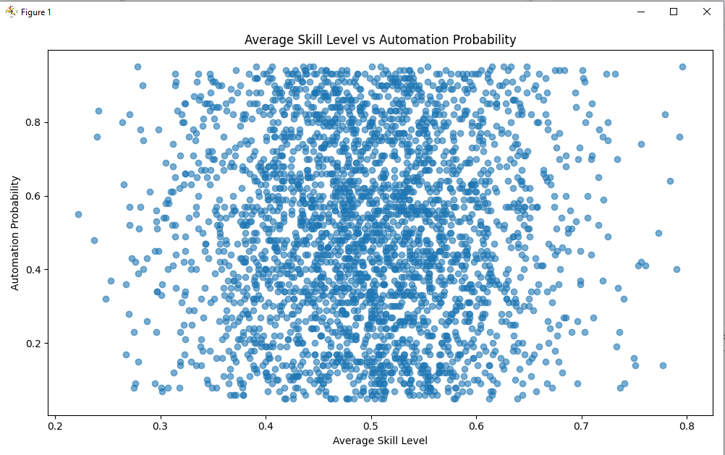
Average skill level was manually computed for each job.
A scatterplot shows a negative relationship:
- Higher skill levels → lower automation risk
- Low‑skill jobs → higher vulnerability
Skill‑intensive roles are harder to automate due to complexity, judgment, and creativity.

5.6 Automation Probability by Education Level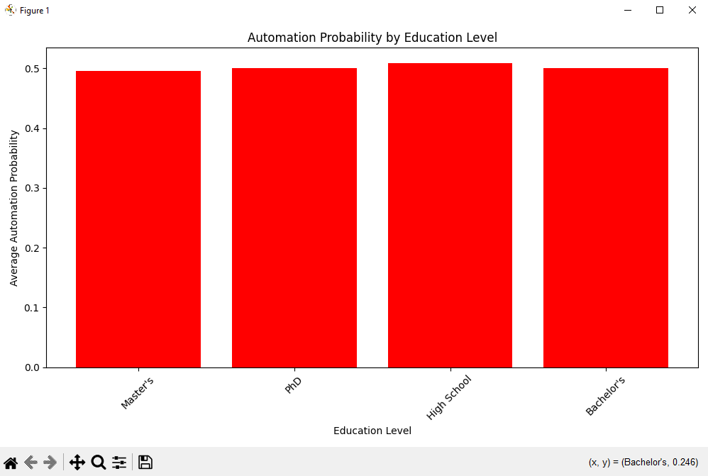
The average automation probability was nearly identical across all four education levels (High School, Bachelor’s, Master’s, PhD), with values clustering around 0.50. This indicates that education level is not a meaningful predictor of automation risk in this dataset. The wide spread within each group suggests that job type, not education, determines vulnerability.

5.7 Experience vs. Automation Probability
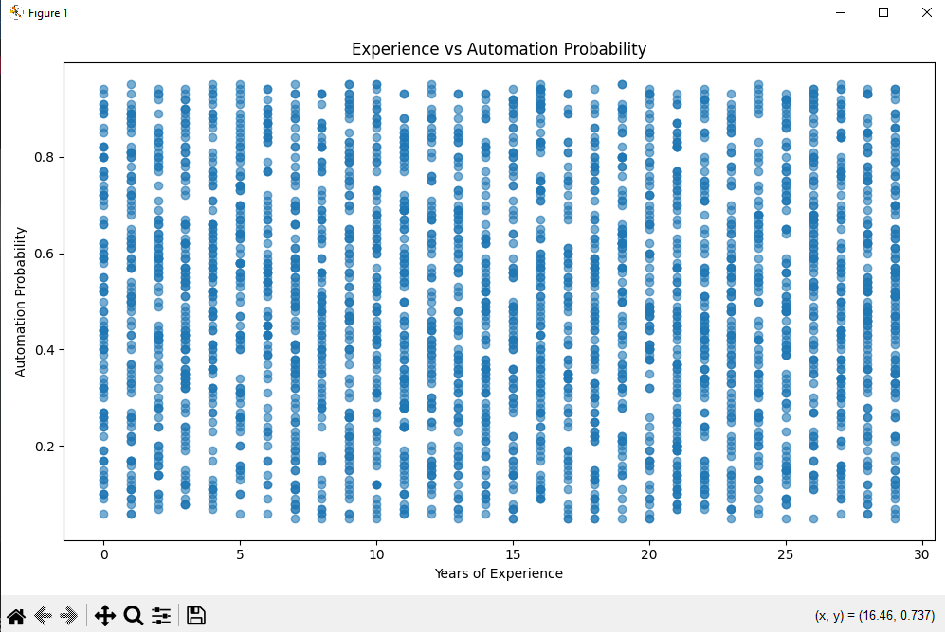
The scatterplot shows no meaningful relationship between years of experience and automation probability. Jobs requiring 0 years of experience can be either low‑risk or high‑risk, and the same is true for jobs requiring 20+ years. This is expected because experience is not used as an input in the dataset’s automation‑risk estimation model.

5.8 Top 10 Most and Least Automatable Jobs
The rankings reveal:
- Most automatable jobs involve repetitive, structured tasks
Most Automatable Jobs (Averaged):
- Job Title Avg Automation Probability
- Retail Worker 0.8347
- Security Guard 0.8331
- Construction Worker 0.8260
- Customer Support 0.8253
- Truck Driver 0.8186
- Graphic Designer 0.5290
- Software Engineer 0.5087
- Data Scientist 0.4963
- Chef 0.4957
- Marketing Manager 0.4948

- Least automatable jobs require creativity, judgment, or specialized expertise
Least Automatable Jobs (Averaged):
- Job Title Avg Automation Probability
- UX Researcher 0.4924
- HR Specialist 0.4908
- Lawyer 0.4864
- Mechanic 0.4853
- Financial Analyst 0.4851
- Doctor 0.1767
- Teacher 0.1758
- Nurse 0.1756
- Research Scientist 0.1742
- AI Engineer 0.1722
These lists illustrate how AI may reshape the labor market.

6. Discussion
Several consistent themes emerge:

6.1 Skills Matter
Higher skill levels correlate with lower automation risk. Skill‑intensive jobs require judgment, creativity, or complex decision‑making—areas where AI still struggles.

6.2 Education Matters
Education level does not significantly influence automation risk in this dataset. All four education categories show nearly identical average automation probabilities. This suggests that job characteristics—not formal education—drive automation vulnerability.

6.3 AI Exposure Is a Double‑Edged Sword
Jobs with high AI exposure are more likely to be automated. AI tools may eventually replace the tasks they currently augment.

6.4 Experience Provides Stability
Experience does not appear to influence automation risk. The dataset’s automation‑probability model does not incorporate experience as a factor, which explains the lack of correlation in the scatterplot.

6.5 Risk Categories Align with Economic Theory
High‑risk jobs tend to be:
- Lower‑skill
- Lower‑salary
- Routine
Low‑risk jobs tend to be:
- Higher‑skill
- Higher‑salary
- Non‑routine
However, salary and education level do not meaningfully differentiate risk categories in this dataset, contrary to common assumptions.

7. Conclusion
This project demonstrates how probability and statistics can be applied to analyze the future of work in an AI‑driven economy. By manually computing averages, correlations, and distributions—and by visualizing key relationships—we gain insight into which jobs are most vulnerable to automation and why.
Key takeaways:
- Automation risk varies widely across job types.
- Routine, predictable jobs face the highest risk.
- Human‑centric and specialized roles remain the safest.
- Education level does not meaningfully predict automation risk.
- Experience does not correlate with automation risk.
- Salary distribution is uniform and not strongly tied to automation probability.
- AI exposure has a very weak positive correlation with automation probability (r ≈ 0.014).
- Job characteristics—task structure, creativity, and human interaction—are the strongest predictors of job safety.
While AI will reshape the labor market, workers with strong skills, higher education, and experience appear most resilient.

8. Key Parameters
Parameter | Value | Description
Number of jobs | 3000 | Total professions analyzed in the dataset
Skill indicators | 10 | Used to compute the Average Skill Level variable
Education levels | 4 | High School, Bachelor’s, Master’s, and PhD
Correlation | r = 0.0143 | Correlation between AI exposure and automation probability
Highest‑risk job | Retail Worker (0.8347 average automation probability) | Most automatable job category
Lowest‑risk job | AI Engineer (0.1722 average automation probability) | Least automatable job category

Limitations

This dataset contains only 20 unique job titles repeated across 3000 rows, which limits the diversity of job types. Skill indicators are tightly clustered, reducing their predictive power. Automation probabilities are estimates rather than measured outcomes, and the model does not incorporate factors such as experience or industry‑specific constraints. These limitations should be considered when interpreting the results.

9. Code Summary

All statistical computations and visualizations were performed programmatically using Python. The analysis used pandas for data manipulation, matplotlib for plotting, and custom functions for manual calculations such as correlation, sample means, and average skill level. The code also handled data cleaning, duplicate removal, and grouping operations for job‑level averages.

10. List of Figures
- Automation Probability by Job Title
- AI Exposure vs Automation Probability
- Automation Probability Distribution
- Salary Distribution
- Skill Level vs Automation Probability
- Automation Probability by Education Level
- Experience vs Automation Probability
- Salary by Risk Category
- Top 10 Most Automatable Jobs
- Top 10 Least Automatable Jobs

